Videos to download from youtube

[MyLink Overview - Somfy Automation](https://youtu.be/S4DTtSTdSpI)

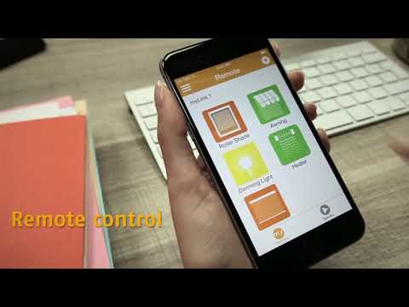

[NZWS Somfy® MyLink Changing WIFI Network Information](https://youtu.be/m93_hAy7zy0)

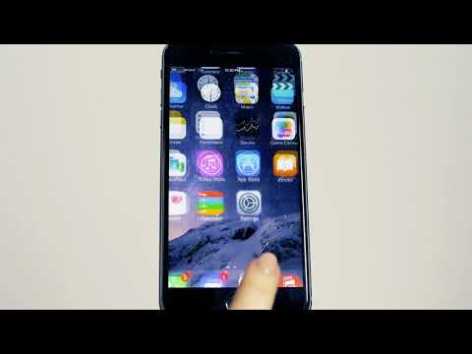

[NZWS Somfy® MyLink Join Existing System](https://youtu.be/63G6zAVvKw8)

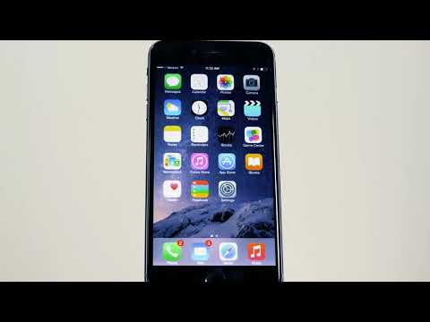

[NZWS Somfy® MyLink Initial Setup & RTS Programming](https://youtu.be/iZQxcCCcZDU)

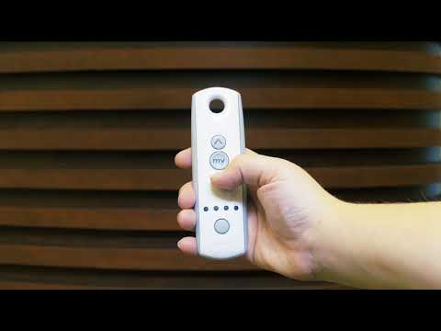

[NZWS Somfy® MyLink Create & Execute Schedules](https://youtu.be/fIg3OzgymwM)

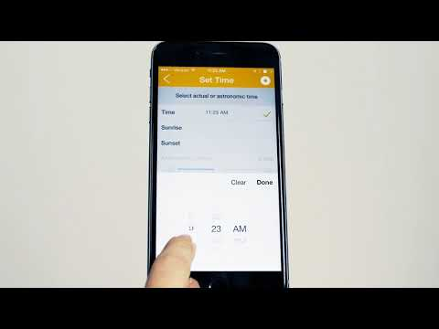

[NZWS Somfy® MyLink Create & Execute Scenes](https://youtu.be/XejwwNkC_8Y)

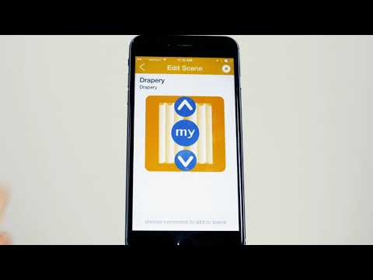

[NZWS Somfy® MyLink App Overview & Basic Navigation](https://youtu.be/Ooo-T_pWhxk)

