Videos to download from youtube

[Pairing The Remote - Photon One Solar](https://youtu.be/ZdAdF94tjSM)

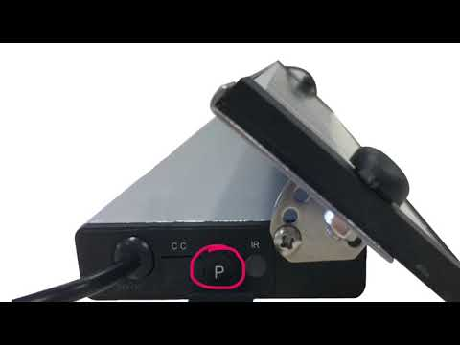

[Changing Motor Direction - Photon One Solar](https://youtu.be/OLWslS4xRo0)

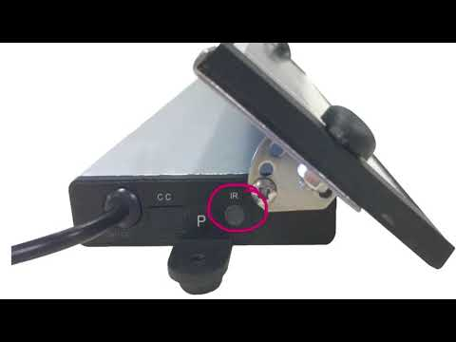

[Setting Motor Limits - Photon One Solar](https://youtu.be/PRzcDrv_WQ8)

